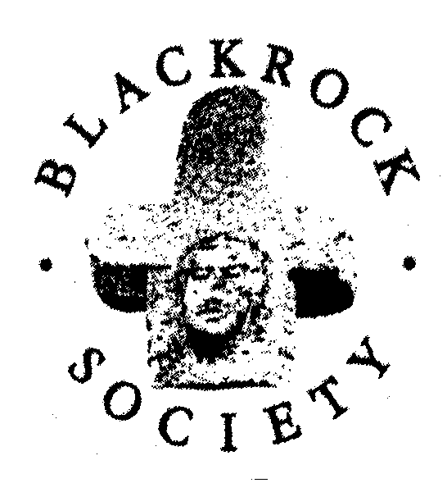

PROCEEDINGS
OF BLACKROCK SOCIETY
Each year, the Society publishes an illustrated journal containing all the lectures given during that year. The latest edition available is for 2018. Back copies of the Proceedings over the years are available, going back to the early 1990s.
Price €7.50 per copy plus €1.70 for postage and packaging.

Please complete the form below and send it, together with your cheque, to:
David Houston – email: houston261 at eircom.net
Treasurer, Blackrock Society
1 Merville Avenue
Stillorgan, Co. Dublin

Cheques should be made payable to ‘Blackrock Society’.

……………………………………………………………………………...............................................
PROCEEDINGS OF THE BLACKROCK SOCIETY
ORDER FORM FOR THE YEAR(S) __________

I would like to order a copy/copies of the Proceedings for the year
[please fill in year, e.g. 2018] and enclose cheque for €7.50 per copy plus €1.70 for postage and packaging.

Name: _______________________________________________________________

Address: _____________________________________________________________

____________________________________________________________

Telephone: ___________________________________________________________

Date: ________________________________________________________________

E-mail (for correspondence – please PRINT): ________________________________

